# Lab Programs And Algorithms

**1**) Design a data frame for manipulating the student record it consist of roll no, name, mark of

Five subject .List the details of student those who have score maximum mark and score the

toppest mark in each and every subject.

**Algorithm**

Step 1: Start

Step2: Import the package we needed in this program(import pandas as pd)

Step3: Design a data frame name data containing record of student consist

of name, roll no, mark of five subjects.

Step4: Store the data in df that means df=pd.DataFrame(Data).

Step5: Then print our dataframe.

Step6: Print who have to score maximum mark in each and every subject so

we do df[“name”].loc[df[“subject name”].idxmax()],df[“subject name”]

.loc[df[“subject name”].idxmax()]/*this will always print the name of

Student who score maximum mark in subject/*

Step7: Stop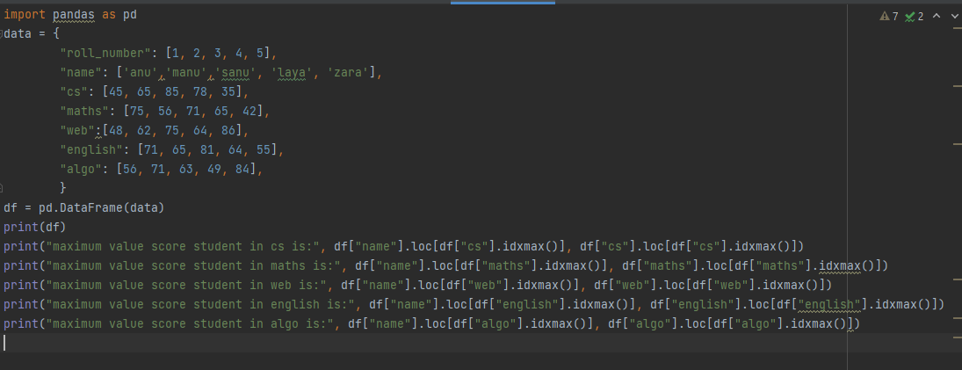

**2**) Download and read any numeric dataset available in a public space .Find the standard

Deviation of each and every column

**Algorithm**

Step1: start

Step2: Download a csv file

Step3: Import pandas as pd

Step4: From math import sqrt(in this program some mathematical functions are performed so we

want to import this)

Step4: Read the csv file and store in a variable

Step5: Print csv file

Step6: column=file.columns

Step7: for I in column, set sum=0,if i==”unnamed==0”,continue

Step8: for j in file[i],sum+=j,

Step9: Repeat step7 and 8 until the whole column is traversed: Then go to step10

Step 10: mean=sum/len(file[i])

Step11: set var=0

Step12: for j in file[i]:

Step13: sum+=j

Step14: mean=sum/length(file[i]-1),std=sqrt(variance)

Step15: Print standard deviation

Step 16: Stop

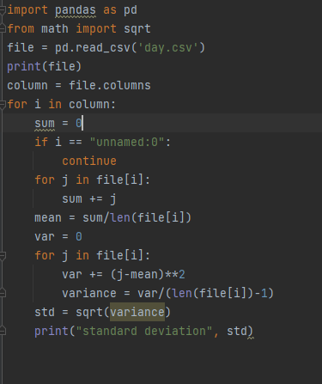

**3)** Download and read any numeric data anf find min,maximum,meadian in each and every

Column

**Algorithm**

Step1: Start

Step 2: Import pandas.pd

Step3: Read csv file

Step4: Calculate mean,min, max

Step5: Print min max mean

Step6: Stop

**4**) Download any numeric dataset.Normalized the dataset with any function for normalization

**Algorithm**

Step1: Start

Step2: From sklearn import preprocessing

Step3: Import pandas as pd

Step4: Read csv file and store in variable

Step5:Preprocessing.normalize (csvfile)

Step6: Normalize the columns in csv file

Step 7: Print the normalize dataset.

Step8: Stop

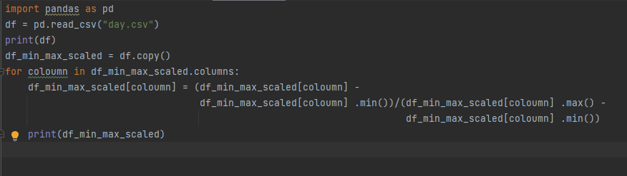

**5**) Download any categorical dataset and convert it in to numerical data by applying some

Mechanism.

**Algorithm**

Step1: Start

Step2: Import pandas as pd

Step3: Read the download csv file

Step4: pd.get_dummies(df[“purchased”])

Step5: pd.conct([df,df1],axis=1).reindex(df.index)

Step6: df.drop(“purchased”,axis=1,inplace=”True”)

Step7: Print the new dataset

Step8: Stop

